Chapter 11, Solution 51.

For the entire circuit in Fig. 11.70, calculate:

(a) the power factor
(b) the average power delivered by the source
(c) the reactive power
(d) the apparent power
(e) the complex power

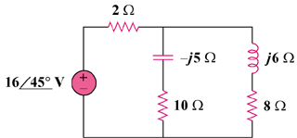

Figure 11.70
For Prob. 11.51.

Solution

31.12 W

- 2.932 VAR

- 31.26 VA

- (31.12+j2.932) VA

(a) 0.9956 (lagging, (b) 31.12 W, (c) 2.932 VAR, (d) 31.26 VA, (e) [31.12+j2.932] VA

